EELISA InnoCORE Diversity Award

Awarding and rewarding diversity – Recognising researchers and innovators particularly committed with diversity
EELISA InnoCORE is gathering good practices and actions put in place by individual researchers and research structures (groups, departments, laboratories, centres) promoting diversity within research and innovation teams, and thus fostering the existence of diverse and inclusive research and innovation communities.
‘Diversity’ describes the fact that differences exist and it is a positive aspect of society that should be acknowledged, welcomed and fostered so that all people are able to fully participate in society.
In this context, we are looking for good practices, actions and initiatives touching upon any of these aspects (excluding gender):
- Disability;
- Ethnic/cultural/migration background;
- Socio-economic background;
- Sexual identity (including LGBT+);
- Education background (alternative pathways, lifelong learner);
- Caring responsibilities; Religious background/beliefs;
- Age.

As already mentioned, we are looking particularly for actions aimed to support diversity within your research and innovation teams.
Workshop and award “Building a diverse and inclusive workforce among our academic and non-academic staff”
We will invite the best selected good practices to present their initiatives during a workshop in the framework of the I EELISA International Conference that will take place Bucharest in October. The best practice will be recognised with the I EELISA Diversity Award. The award is a non-monetary recognition. Travel, accommodation and subsistence expenses must be covered by your sending organisation. Please check with your organisation.

Jury
Both the selection of good practices to be presented during the workshop and the selection of the winner of the I EELISA Diversity Award will be done by EELISA Gender and Diversity Work Group. The selection of good practices will be done during the month of July. The selection of the winner will be done after the presentation of the good practices in Bucharest, at the end of the workshop.
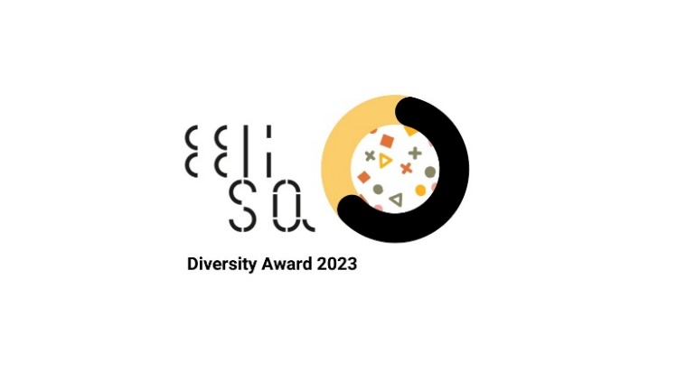

Criteria
When evaluating the good practices, the jury will consider the following non-exhaustive list of criteria:
- Impact: the good practice has contributed to significantly promote diversity, inclusion and cultural competency development among the workforce.
- Innovative character of the good practice.
- Reach out: engagement and collaboration with other stakeholders.

Applications
Applicants must be researchers, including PhD students, academic staff and non-academic staff from EELISA universities.
Please send your good practices by email before 30 June 2023 to isabel.salgueiro@upm.es using the template in Annex I.

Annex I

Awarding and rewarding diversity – Recognising researchers and innovators particularly committed with diversity

Contact details:

Name and surname:

Institution:

Role:

Contact email:

What aspect of diversity does your good practice address?
Disability | ☐
Ethnic/ cultural / migration background | ☐
Socio-economic background | ☐
Sexual identity (including LGBT+) | ☐
Education background (alternative pathways, lifelong learner) | ☐
Caring responsibilities | ☐
Religious background/beliefs | ☐
Age | ☐

Good practice description:

Name or title of the action or initiative:

Brief description (minimum 200 words):

Gender is excluded due to the already-done intense mapping of measures and the important number of activities already organised under this topic in EELISA and EELISA InnoCORE.

